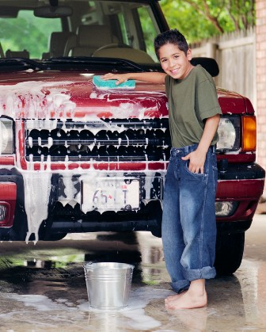

**2-4 year olds**

Help dust  
Put napkins on table  
Help put away toyshttp://www.assoc-amazon.com/e/ir?t=parenting-books-and-more-20&l=ur2&o=1  
Put laundry in hamperhttp://www.assoc-amazon.com/e/ir?t=parenting-books-and-more-20&l=ur2&o=1  
Help feed pet  
  
**4-7year olds** - "Help" is the important word at this age. Many of the chores will be done as a helper and slowly kids can graduate to doing them independently!

Set the table or help set the table  
Put away toys/things  
Help feed pets  
Water plants  
Help set table  
Help make bed  
Dust  
Put laundry in hamperhttp://www.assoc-amazon.com/e/ir?t=parenting-books-and-more-20&l=ur2&o=1  
Help put dishes in dishwasher  
Water the garden  
Help wipe up messes  
Help with yard work (rake with child's rake or plant flowers, etc.)  
Help clear table

The chores suggested below are a rough guideline of age appropriate jobs for kids. Keep in mind that kids are different both developmentally and physically. Some children may be able to handle more than others, some less. You need to decide what chores are appropriate for your kids. It's a good idea to start small and add chores based on your child's readiness. It's even o.k. to start with one chore, especially if assigning chores is new in your family. We want our kids to succeed so we need to set up a system that supports success!

**8-10 year olds**

Make bed  
Water plants  
Clean room with direction  
Set table  
Dust  
Vacuum  
Feed pets (depends on type of pet and how your comfortable your child is interacting with the pet)  
Help make dinner  
Put laundry in hamperhttp://www.assoc-amazon.com/e/ir?t=parenting-books-and-more-20&l=ur2&o=1  
Help wash the car  
Help wash dishes  
Help load/empty dishwasher  
Rake leaveshttp://www.assoc-amazon.com/e/ir?t=parenting-books-and-more-20&l=ur2&o=1  
  
**11 year olds and older**

Take garbage out  
Set table  
Clean room with direction  
Vacuum  
Mow lawn  
Feed/Care for pets  
Water plants  
Put laundry in hamper  
Help with laundry and eventually start doing own laundry  
Help make dinner/make small meals on own   
Help wash the car/wash car  
Clean room  
Make bed  
Help with yard work  
Shovel snow  
Wash dishes/load or empty dishwasher